Point-Asymmetric Shapes

Definition
# Source: AI Source: Provided by: [Data Path: Persons Table -> ID Column: 1, Name_En Column: Motasem Essam] -> From: [ChatGPT] on [7/25/2026]
Point-Asymmetric Shapes are shapes that do not remain unchanged under point reflection (central symmetry) about a specified center point.
For a shape $S$and a point $O$, if a ${180}^{∘}$rotation about $O$produces a different shape, then:
$$\boxed{R_{O,{180}^{∘}}\left(S\right)≠S}$$
The shape is therefore point-asymmetric about $O$.
Important: Point-asymmetric means asymmetric with respect to point reflection / ${180}^{∘}$rotational symmetry. It does not necessarily mean that the shape has no other type of symmetry.
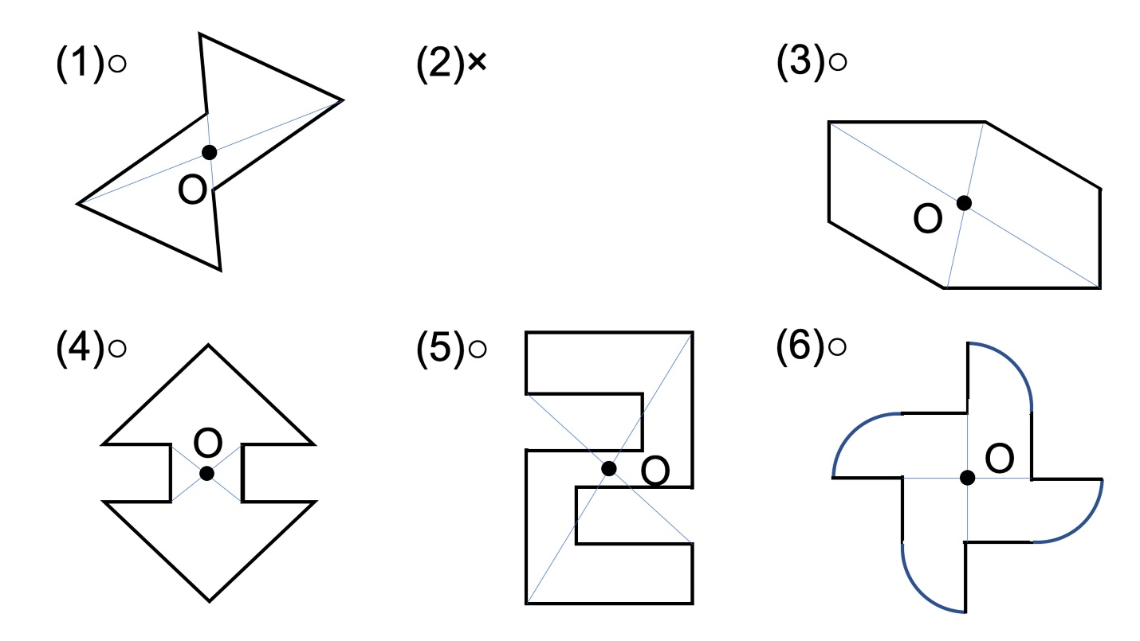
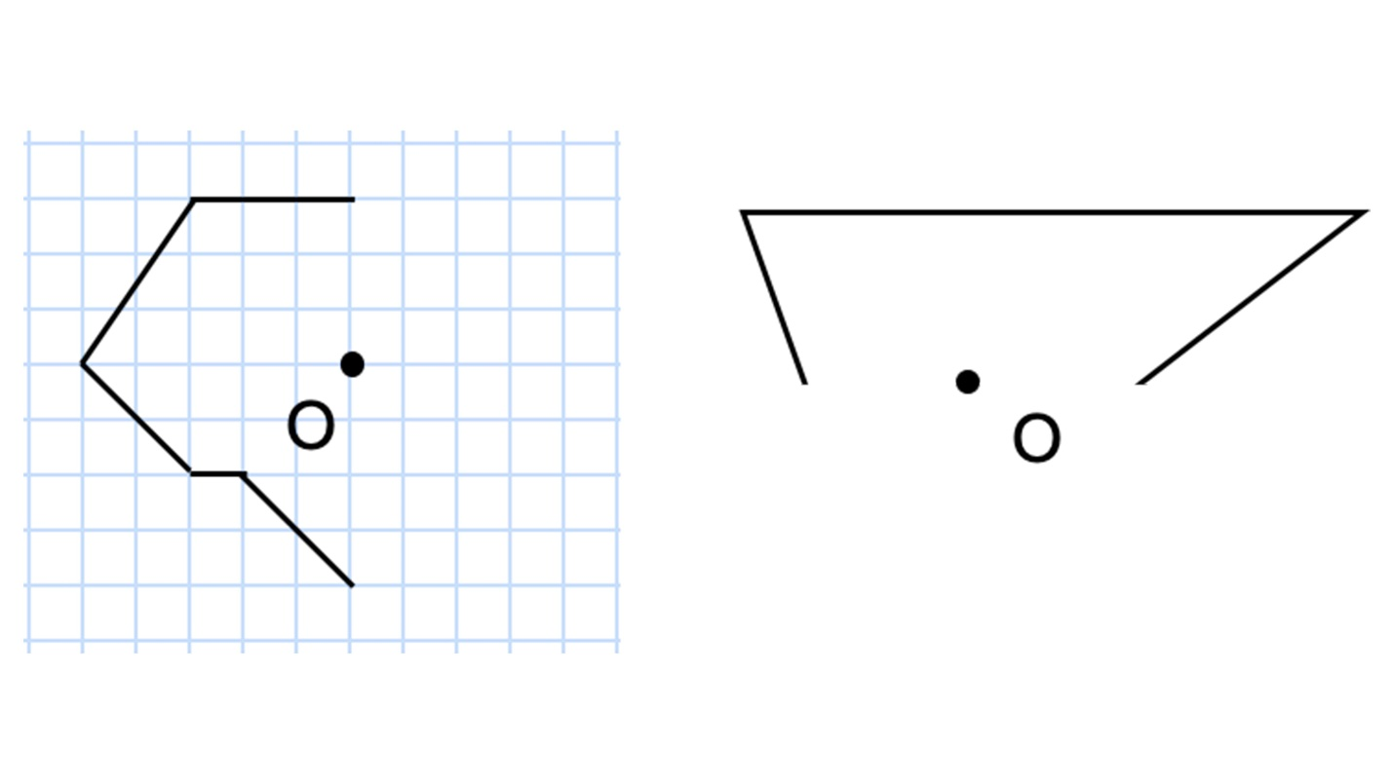
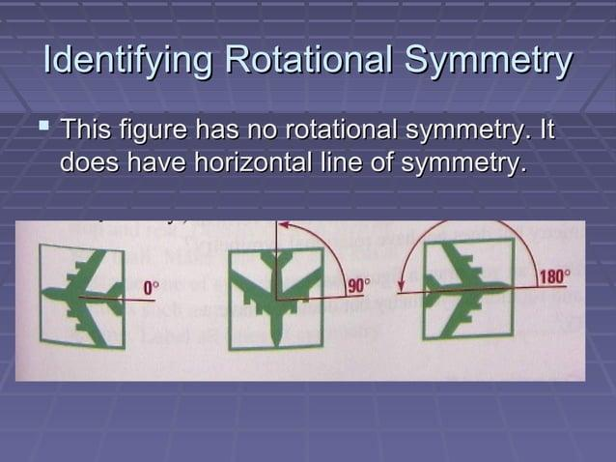
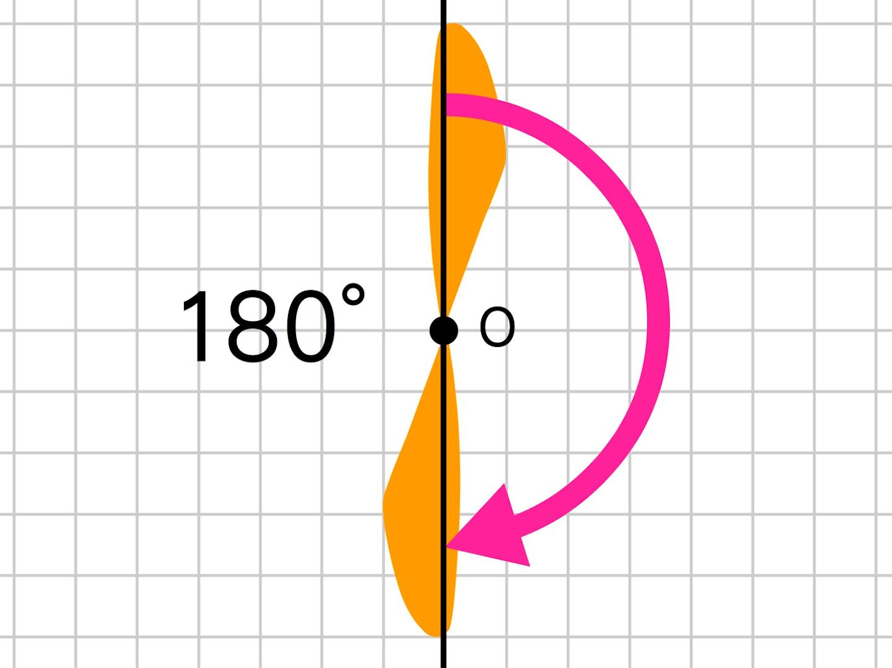

Fundamental Concept
# Source: AI Source: Provided by: [Data Path: Persons Table -> ID Column: 1, Name_En Column: Motasem Essam] -> From: [ChatGPT] on [7/25/2026]
Point symmetry, also called central symmetry, occurs when every point of a shape has a corresponding point on the opposite side of a center point at the same distance.
If $P$is a point on the shape and $P^{'}$is its corresponding point, then the center $O$satisfies:
$$\boxed{O\text{ is the midpoint of }\overset{‾}{PP^{'}}}$$
Equivalently:
$$\boxed{\vec{OP^{'}}=-\vec{OP}}$$
A shape that does not satisfy this condition for all corresponding points is point-asymmetric.

Point-Asymmetry Condition
# Source: AI Source: Provided by: [Data Path: Persons Table -> ID Column: 1, Name_En Column: Motasem Essam] -> From: [ChatGPT] on [7/25/2026]
Let $S$be a shape and $O$its proposed center.
Under point reflection about $O$:
$$P→P^{'}$$
where:
$$\boxed{P^{'}=2O-P}$$
For a point $O=\left(h , k\right)$and $P=\left(x , y\right)$:
$$\boxed{P^{'}=\left(2 , h-x 2k-y\right)}$$
If the transformed shape differs from the original:
$$\boxed{R_{O,{180}^{∘}}\left(S\right)≠S}$$
then the shape is point-asymmetric about $O$.

Main Characteristics
# Source: AI Source: Provided by: [Data Path: Persons Table -> ID Column: 1, Name_En Column: Motasem Essam] -> From: [ChatGPT] on [7/25/2026]
Point-asymmetric shapes generally have one or more of these characteristics:
- No center of point symmetry
- Unequal features on opposite sides of a potential center
- Non-matching opposite regions
- Uneven distribution around a center
- No ${180}^{∘}$rotational symmetry
- Different arrangements after a half-turn
However, irregularity is not required.
A shape may be geometrically well-defined and still be point-asymmetric.

Types of Point-Asymmetric Shapes
# Source: AI Source: Provided by: [Data Path: Persons Table -> ID Column: 1, Name_En Column: Motasem Essam] -> From: [ChatGPT] on [7/25/2026]
Point-asymmetric shapes can be classified according to their geometric structure:
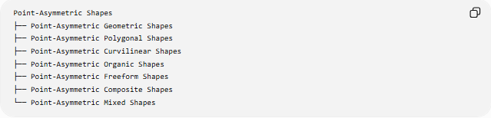
Point-Asymmetric Shapes
├── Point-Asymmetric Geometric Shapes
├── Point-Asymmetric Polygonal Shapes
├── Point-Asymmetric Curvilinear Shapes
├── Point-Asymmetric Organic Shapes
├── Point-Asymmetric Freeform Shapes
├── Point-Asymmetric Composite Shapes
└── Point-Asymmetric Mixed Shapes

Point-Asymmetric Geometric Shapes
# Source: AI Source: Provided by: [Data Path: Persons Table -> ID Column: 1, Name_En Column: Motasem Essam] -> From: [ChatGPT] on [7/25/2026]
These are geometric shapes that do not have point symmetry about any relevant center.
Examples
- Scalene triangles
- Isosceles triangles
- Most irregular quadrilaterals
- Many irregular polygons
- Uneven geometric arrangements
For example, a triangle cannot have point symmetry because a ${180}^{∘}$rotation would not reproduce the same triangular arrangement.
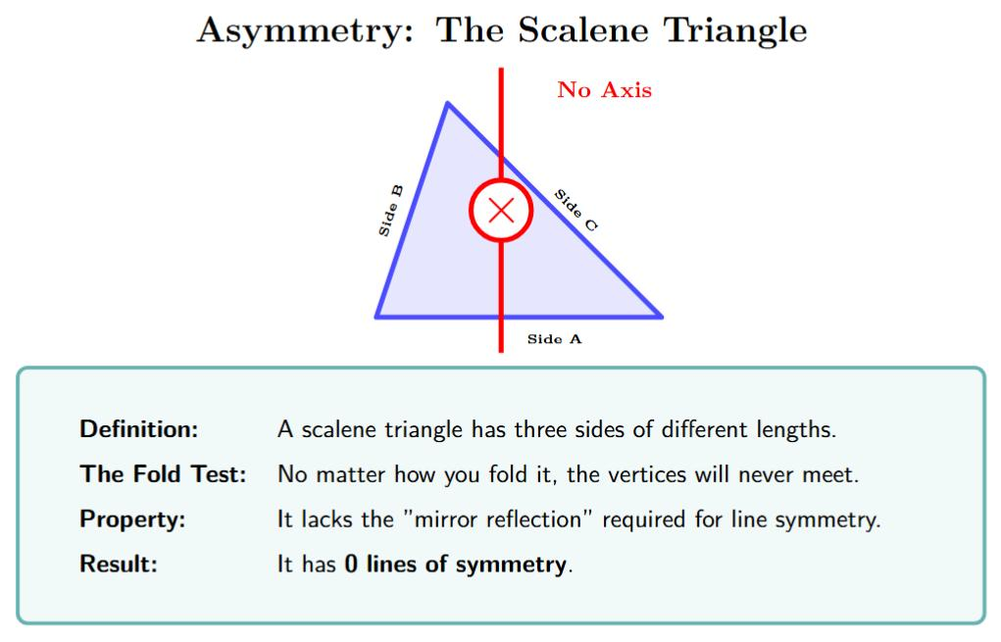
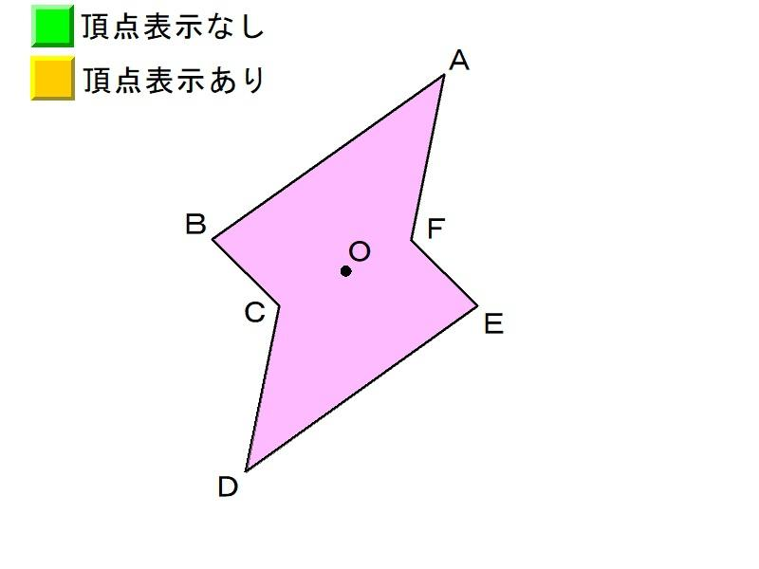

Point-Asymmetric Polygonal Shapes
# Source: AI Source: Provided by: [Data Path: Persons Table -> ID Column: 1, Name_En Column: Motasem Essam] -> From: [ChatGPT] on [7/25/2026]
A polygon is point-asymmetric when it does not coincide with itself after a ${180}^{∘}$rotation about any point.
Examples
- Triangles
- Irregular quadrilaterals
- Irregular pentagons
- Many irregular hexagons
- Concave polygons without central symmetry
Important distinction
Not every polygon is point-asymmetric.
For example:
- Rectangle → has point symmetry
- Parallelogram → has point symmetry
- Regular hexagon → has point symmetry
- Triangle → does not have point symmetry
Therefore:
$$\boxed{\text{Polygon}≠\text{Point-Asymmetric}}$$
Point symmetry depends on the arrangement of the polygon's vertices and edges.

Point-Asymmetric Curvilinear Shapes
# Source: AI Source: Provided by: [Data Path: Persons Table -> ID Column: 1, Name_En Column: Motasem Essam] -> From: [ChatGPT] on [7/25/2026]
These are shapes with curved boundaries that do not reproduce themselves under a ${180}^{∘}$rotation.
Examples include:
- Irregular curved regions
- Uneven curved outlines
- Asymmetric freeform curves
- Irregular combinations of circular or elliptical arcs
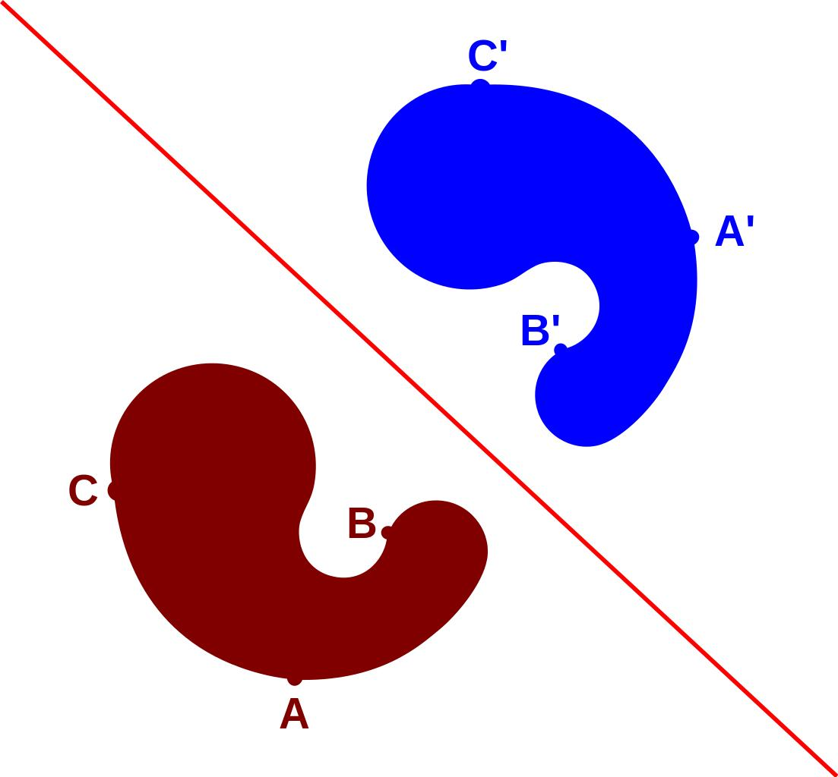
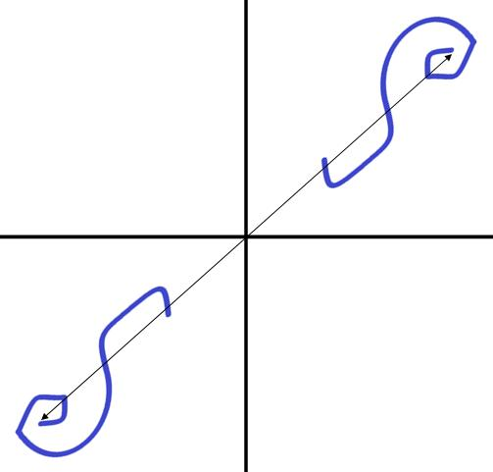
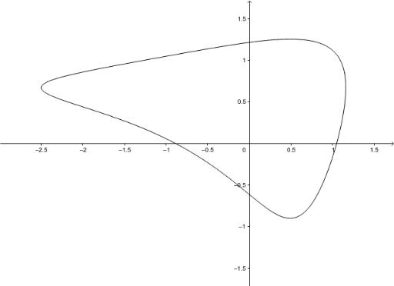
A curve may be smooth and continuous while still being point-asymmetric.

Point-Asymmetric Organic Shapes
# Source: AI Source: Provided by: [Data Path: Persons Table -> ID Column: 1, Name_En Column: Motasem Essam] -> From: [ChatGPT] on [7/25/2026]
Many natural and organic forms are point-asymmetric because their structures are not arranged in opposite matching pairs.
Examples include:
- Irregular leaf-like forms
- Natural blobs
- Rock-like shapes
- Uneven biological forms
- Irregular natural outlines
However, organic appearance does not automatically imply point-asymmetry.

Point-Asymmetric Freeform Shapes
# Source: AI Source: Provided by: [Data Path: Persons Table -> ID Column: 1, Name_En Column: Motasem Essam] -> From: [ChatGPT] on [7/25/2026]
A freeform shape is point-asymmetric when rotating it ${180}^{∘}$about a proposed center does not reproduce the original shape.
Examples include:
- Abstract freeform shapes
- Freeform curved shapes
- Freeform mixed shapes
- Decorative freeform shapes
The two concepts describe different properties:
$$\boxed{\text{Freeform}≠\text{Point-Asymmetric}}$$
A freeform shape can have point symmetry, while another freeform shape may not.

Point-Asymmetric Composite Shapes
# Source: AI Source: Provided by: [Data Path: Persons Table -> ID Column: 1, Name_En Column: Motasem Essam] -> From: [ChatGPT] on [7/25/2026]
A composite shape consists of multiple components.
It is point-asymmetric when the overall arrangement of its components does not reproduce itself after a ${180}^{∘}$rotation.
For example:
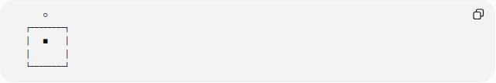
○
┌────────┐
│ ■ │
│ │
└────────┘
If the components do not have corresponding components at equal distances on opposite sides of the center, the whole arrangement is point-asymmetric.
Important
Individual components can possess symmetry while their combined arrangement does not.

Point-Asymmetric Mixed Shapes
# Source: AI Source: Provided by: [Data Path: Persons Table -> ID Column: 1, Name_En Column: Motasem Essam] -> From: [ChatGPT] on [7/25/2026]
These shapes combine different geometric elements, such as:
- Straight segments
- Circular arcs
- Elliptical curves
- Freeform curves
- Different geometric regions
If the complete arrangement does not reproduce itself after a ${180}^{∘}$rotation, it is point-asymmetric.
For example:
$$\text{Circle}+\text{irregular polygon}+\text{freeform curve}$$
can form a point-asymmetric mixed shape.

Point Symmetry and ${180}^{∘}$Rotation
# Source: AI Source: Provided by: [Data Path: Persons Table -> ID Column: 1, Name_En Column: Motasem Essam] -> From: [ChatGPT] on [7/25/2026]
Point symmetry is directly related to a half-turn.
A point-symmetric shape satisfies:
$$\boxed{R_{O,{180}^{∘}}\left(S\right)=S}$$
A point-asymmetric shape satisfies:
$$\boxed{R_{O,{180}^{∘}}\left(S\right)≠S}$$
Therefore:
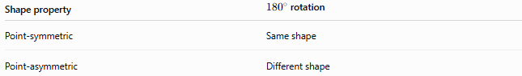
Shape property | ${180}^{∘}$rotation
Point-symmetric | Same shape
Point-asymmetric | Different shape
This makes point symmetry a special case of rotational symmetry.

Point-Asymmetric vs Rotation-Asymmetric
# Source: AI Source: Provided by: [Data Path: Persons Table -> ID Column: 1, Name_En Column: Motasem Essam] -> From: [ChatGPT] on [7/25/2026]
These terms are closely related but should be distinguished carefully.
Rotation-asymmetric
A shape has no non-trivial rotational symmetry.
Point-asymmetric
A shape has no ${180}^{∘}$rotational symmetry about the specified center.
Therefore:
$$\boxed{\text{Point-asymmetric}⇒\text{rotation-asymmetric}}$$
when "rotation-asymmetric" means no non-trivial rotational symmetry at all.
However, the reverse is not a separate possibility in this context: if a shape has any rotational symmetry of order $n≥3$, it can still lack ${180}^{∘}$symmetry.
For example, an equilateral triangle has rotational symmetry of order $3$, but it is point-asymmetric because a ${180}^{∘}$rotation does not reproduce it.
Thus:
$$\boxed{\text{Rotation-asymmetric}≢\text{Point-asymmetric}}$$
because a shape can have rotational symmetry without having point symmetry.

Point-Asymmetric vs Reflection-Asymmetric
# Source: AI Source: Provided by: [Data Path: Persons Table -> ID Column: 1, Name_En Column: Motasem Essam] -> From: [ChatGPT] on [7/25/2026]
These are different symmetry tests.
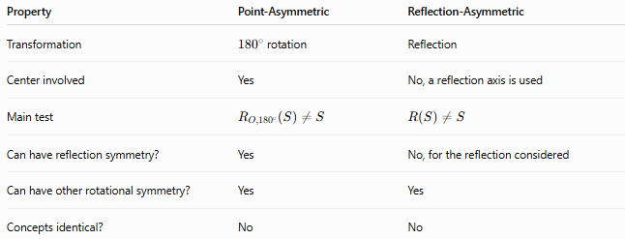
Property | Point-Asymmetric | Reflection-Asymmetric
Transformation | ${180}^{∘}$rotation | Reflection
Center involved | Yes | No, a reflection axis is used
Main test | $$R_{O,{180}^{∘}}\left(S\right)≠S$$ | $$R\left(S\right)≠S$$
Can have reflection symmetry? | Yes | No, for the reflection considered
Can have other rotational symmetry? | Yes | Yes
Concepts identical? | No | No
For example, an equilateral triangle:
- Has reflection symmetry.
- Has ${120}^{∘}$rotational symmetry.
- Does not have point symmetry.
Therefore, it is:
$$\boxed{\text{Point-asymmetric but reflection-symmetric}}$$

Point-Asymmetry vs Irregularity
# Source: AI Source: Provided by: [Data Path: Persons Table -> ID Column: 1, Name_En Column: Motasem Essam] -> From: [ChatGPT] on [7/25/2026]
These properties are independent.
$$\boxed{\text{Irregularity}≠\text{Point-Asymmetry}}$$
An irregular shape may still have point symmetry.
Example
A non-square rectangle is irregular as a regular polygon because its sides/angles do not all satisfy regular-polygon conditions, but it has point symmetry at the intersection of its diagonals.
Conversely, a shape can be carefully constructed with equal or repeating features but still lack point symmetry.

Point-Asymmetry vs Complete Asymmetry
# Source: AI Source: Provided by: [Data Path: Persons Table -> ID Column: 1, Name_En Column: Motasem Essam] -> From: [ChatGPT] on [7/25/2026]
Point-asymmetry only concerns one particular transformation:
$${180}^{∘}\text{ rotation}$$
A point-asymmetric shape may still have:
- Reflection symmetry
- Rotational symmetry of another order
- Translational relationships in an arrangement
- Local symmetry within components
Therefore:
$$\boxed{\text{Point-Asymmetric}≠\text{Completely Asymmetric}}$$

Mathematical Representation
# Source: AI Source: Provided by: [Data Path: Persons Table -> ID Column: 1, Name_En Column: Motasem Essam] -> From: [ChatGPT] on [7/25/2026]
For a center:
$$O=\left(h , k\right)$$
a point:
$$P=\left(x , y\right)$$
is mapped by point reflection to:
$$\boxed{P^{'}=\left(2 , h-x 2k-y\right)}$$
The midpoint of $P$and $P^{'}$is:
$$\left(\frac{x+\left(2h-x\right)}{2} , \frac{y+\left(2k-y\right)}{2}\right)$$
which simplifies to:
$$\boxed{\left(h , k\right)}$$
Therefore, $O$is the midpoint of every corresponding pair of points.

Point Symmetry of a Graph
# Source: AI Source: Provided by: [Data Path: Persons Table -> ID Column: 1, Name_En Column: Motasem Essam] -> From: [ChatGPT] on [7/25/2026]
For a function $y=f\left(x\right)$, point symmetry about the origin occurs when:
$$\boxed{f\left(-x\right)=-f\left(x\right)}$$
This is the condition for an odd function.
If:
$$f\left(-x\right)≠-f\left(x\right)$$
then the graph does not have point symmetry about the origin.
Example
$$f\left(x\right)=x^{3}$$
satisfies:
$$f\left(-x\right)={\left(-x\right)}^{3}=-x^{3}=-f\left(x\right)$$
so it has point symmetry about the origin.

Point-Asymmetric Graphs
# Source: AI Source: Provided by: [Data Path: Persons Table -> ID Column: 1, Name_En Column: Motasem Essam] -> From: [ChatGPT] on [7/25/2026]
Consider:
$$f\left(x\right)=x^{2}$$
Then:
$$f\left(-x\right)=x^{2}$$
but:
$$-f\left(x\right)=-x^{2}$$
Therefore:
$$f\left(-x\right)≠-f\left(x\right)$$
The graph does not have point symmetry about the origin.
It does, however, have reflection symmetry about the $y$-axis.
This illustrates that different symmetry types must be tested separately.

Examples

Example 1 — Triangle
# Source: AI Source: Provided by: [Data Path: Persons Table -> ID Column: 1, Name_En Column: Motasem Essam] -> From: [ChatGPT] on [7/25/2026]
A triangle has no point symmetry.
After a ${180}^{∘}$rotation, its vertices do not map back onto the original three vertices.
$$\boxed{\text{Triangle }\text{→} \text{point-asymmetric}}$$

Example 2 — Rectangle
# Source: AI Source: Provided by: [Data Path: Persons Table -> ID Column: 1, Name_En Column: Motasem Essam] -> From: [ChatGPT] on [7/25/2026]
A rectangle has point symmetry about the intersection of its diagonals.
$$R_{O,{180}^{∘}}\left(S\right)=S$$
Therefore:
$$\boxed{\text{Rectangle }\text{→} \text{point-symmetric}}$$

Example 3 — Parallelogram
# Source: AI Source: Provided by: [Data Path: Persons Table -> ID Column: 1, Name_En Column: Motasem Essam] -> From: [ChatGPT] on [7/25/2026]
A parallelogram has point symmetry about the intersection of its diagonals.
Therefore:
$$\boxed{\text{Parallelogram }\text{→} \text{point-symmetric}}$$

Example 4 — Equilateral Triangle
# Source: AI Source: Provided by: [Data Path: Persons Table -> ID Column: 1, Name_En Column: Motasem Essam] -> From: [ChatGPT] on [7/25/2026]
An equilateral triangle has rotational symmetry of order $3$, but not ${180}^{∘}$rotational symmetry.
Therefore:
$$\boxed{\text{Equilateral triangle }\text{→} \text{point-asymmetric}}$$

Example 5 — Circle
# Source: AI Source: Provided by: [Data Path: Persons Table -> ID Column: 1, Name_En Column: Motasem Essam] -> From: [ChatGPT] on [7/25/2026]
A circle has point symmetry about its center because a ${180}^{∘}$rotation maps every point to the opposite point on the circle.
Therefore:
$$\boxed{\text{Circle }\text{→} \text{point-symmetric}}$$

Classification Summary
# Source: AI Source: Provided by: [Data Path: Persons Table -> ID Column: 1, Name_En Column: Motasem Essam] -> From: [ChatGPT] on [7/25/2026]
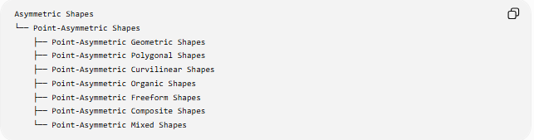
Asymmetric Shapes
└── Point-Asymmetric Shapes
├── Point-Asymmetric Geometric Shapes
├── Point-Asymmetric Polygonal Shapes
├── Point-Asymmetric Curvilinear Shapes
├── Point-Asymmetric Organic Shapes
├── Point-Asymmetric Freeform Shapes
├── Point-Asymmetric Composite Shapes
└── Point-Asymmetric Mixed Shapes
Transformation-based view
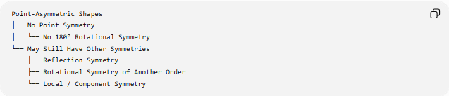
Point-Asymmetric Shapes
├── No Point Symmetry
│ └── No 180° Rotational Symmetry
└── May Still Have Other Symmetries
├── Reflection Symmetry
├── Rotational Symmetry of Another Order
└── Local / Component Symmetry

Key Comparison
# Source: AI Source: Provided by: [Data Path: Persons Table -> ID Column: 1, Name_En Column: Motasem Essam] -> From: [ChatGPT] on [7/25/2026]
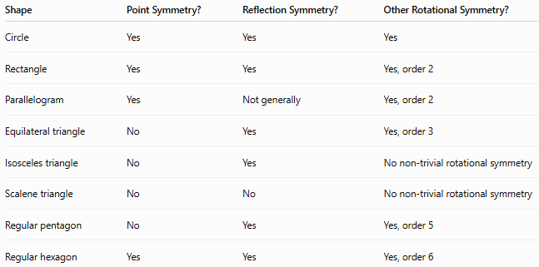
Shape | Point Symmetry? | Reflection Symmetry? | Other Rotational Symmetry?
Circle | Yes | Yes | Yes
Rectangle | Yes | Yes | Yes, order 2
Parallelogram | Yes | Not generally | Yes, order 2
Equilateral triangle | No | Yes | Yes, order 3
Isosceles triangle | No | Yes | No non-trivial rotational symmetry
Scalene triangle | No | No | No non-trivial rotational symmetry
Regular pentagon | No | Yes | Yes, order 5
Regular hexagon | Yes | Yes | Yes, order 6

Key Points
# Source: AI Source: Provided by: [Data Path: Persons Table -> ID Column: 1, Name_En Column: Motasem Essam] -> From: [ChatGPT] on [7/25/2026]
- Point-asymmetric shapes do not have point symmetry about the specified center.
- Point symmetry is equivalent to symmetry under a ${180}^{∘}$rotation.
- For center $O=\left(h , k\right)$, point reflection maps:
$$\left(x , y\right)→\left(2 , h-x2k-y\right)$$
- Every corresponding pair of points has the center as its midpoint.
- Point-asymmetry is different from reflection-asymmetry.
- Point-asymmetry is different from irregularity.
- A shape can be point-asymmetric while still having reflection symmetry.
- A shape can have rotational symmetry of order $3$, $4$, $5$, etc., while still being point-asymmetric if it lacks ${180}^{∘}$symmetry.
- Triangles are point-asymmetric.
- Rectangles, parallelograms, circles, and regular hexagons are point-symmetric.
- Point-asymmetry is a specific symmetry property, not a statement that the shape has no symmetry of any kind.

